82 + 67 =  33 + 19 =  80 + 96 =  18 + 35 =  57 + 12 =  28 + 28 =  2 + 11 =  100 + 7 =  86 + 54 =  52 + 20 =  59 + 14 =  47 + 82 =  48 + 23 =  9 + 87 =  26 + 93 =  73 + 8 =  60 + 6 =  26 + 39 =  2 + 44 =  74 + 58 =  55 + 1 =  86 + 56 =  12 + 85 =  62 + 98 =  38 + 14 = | 17 + 96 =  28 + 63 =  78 + 75 =  86 + 86 =  61 + 11 =  79 + 34 =  18 + 38 =  40 + 44 =  77 + 41 =  87 + 50 =  99 + 42 =  51 + 84 =  98 + 62 =  68 + 59 =  60 + 5 =  73 + 76 =  18 + 18 =  39 + 78 =  75 + 24 =  63 + 36 =  35 + 42 =  70 + 52 =  79 + 9 =  96 + 55 =  50 + 83 = | 4 + 48 =  23 + 55 =  31 + 20 =  16 + 100 =  80 + 76 =  4 + 52 =  52 + 4 =  52 + 91 =  82 + 27 =  14 + 45 =  63 + 48 =  86 + 32 =  100 + 65 =  41 + 96 =  19 + 91 =  78 + 24 =  39 + 1 =  79 + 70 =  22 + 95 =  70 + 1 =  71 + 74 =  53 + 22 =  78 + 5 =  12 + 60 =  32 + 26 =
Meno:__________________
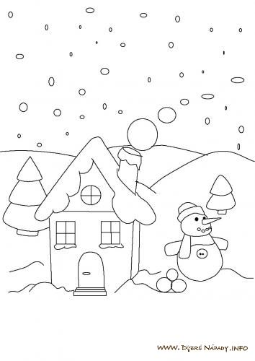

Meno:_____________________________

24 + 52 =  5 + 36 =  66 + 60 =  19 + 41 =  88 + 54 =  77 + 81 =  49 + 28 =  55 + 68 =  21 + 59 =  48 + 35 =  55 + 23 =  94 + 84 =  6 + 84 =  21 + 25 =  14 + 7 =  21 + 37 =  59 + 25 =  73 + 25 =  84 + 92 =  65 + 72 =  45 + 42 =  52 + 94 =  69 + 7 =  61 + 90 =  65 + 9 = | 24 + 19 =  31 + 17 =  3 + 37 =  100 + 24 =  61 + 14 =  31 + 81 =  50 + 90 =  5 + 23 =  14 + 89 =  14 + 79 =  60 + 59 =  20 + 11 =  53 + 89 =  17 + 13 =  78 + 82 =  22 + 1 =  1 + 52 =  18 + 4 =  88 + 18 =  28 + 49 =  31 + 58 =  30 + 81 =  47 + 35 =  3 + 61 =  23 + 17 = | 39 + 82 =  75 + 59 =  93 + 27 =  47 + 9 =  40 + 24 =  91 + 61 =  25 + 92 =  12 + 43 =  95 + 0 =  60 + 22 =  49 + 90 =  80 + 79 =  70 + 26 =  12 + 73 =  87 + 35 =  90 + 25 =  16 + 65 =  84 + 8 =  92 + 31 =  18 + 32 =  56 + 8 =  93 + 81 =  0 + 59 =  23 + 95 =  6 + 84 =

Meno:_____________________________

96 + 8 =  14 + 28 =  80 + 48 =  8 + 35 =  9 + 60 =  42 + 33 =  39 + 12 =  11 + 16 =  51 + 78 =  63 + 73 =  71 + 60 =  91 + 76 =  38 + 80 =  56 + 4 =  65 + 95 =  59 + 61 =  82 + 72 =  89 + 62 =  20 + 97 =  97 + 29 =  56 + 38 =  62 + 95 =  49 + 72 =  10 + 99 =  49 + 72 = | 72 + 19 =  32 + 62 =  95 + 69 =  42 + 51 =  72 + 7 =  45 + 31 =  67 + 27 =  3 + 56 =  88 + 23 =  52 + 84 =  51 + 8 =  21 + 12 =  2 + 69 =  83 + 11 =  68 + 32 =  83 + 39 =  51 + 14 =  1 + 45 =  83 + 42 =  96 + 55 =  49 + 40 =  86 + 15 =  66 + 88 =  71 + 54 =  10 + 22 = | 37 + 60 =  28 + 57 =  72 + 29 =  26 + 55 =  40 + 94 =  86 + 22 =  33 + 36 =  36 + 33 =  81 + 18 =  76 + 76 =  73 + 23 =  15 + 58 =  38 + 81 =  45 + 8 =  34 + 55 =  30 + 71 =  15 + 58 =  28 + 88 =  88 + 55 =  42 + 28 =  48 + 28 =  51 + 82 =  64 + 87 =  14 + 45 =  5 + 91 =

